Ramyasri Singamsetty Partner: Yamini Dasu

EEE 117 Lab – Sergio Aguilar Rudametkin

10 September 2018

LAB 4 PRELAB: LOW PASS FILTERS

Calculations of Transfer Functions of the Four Circuit

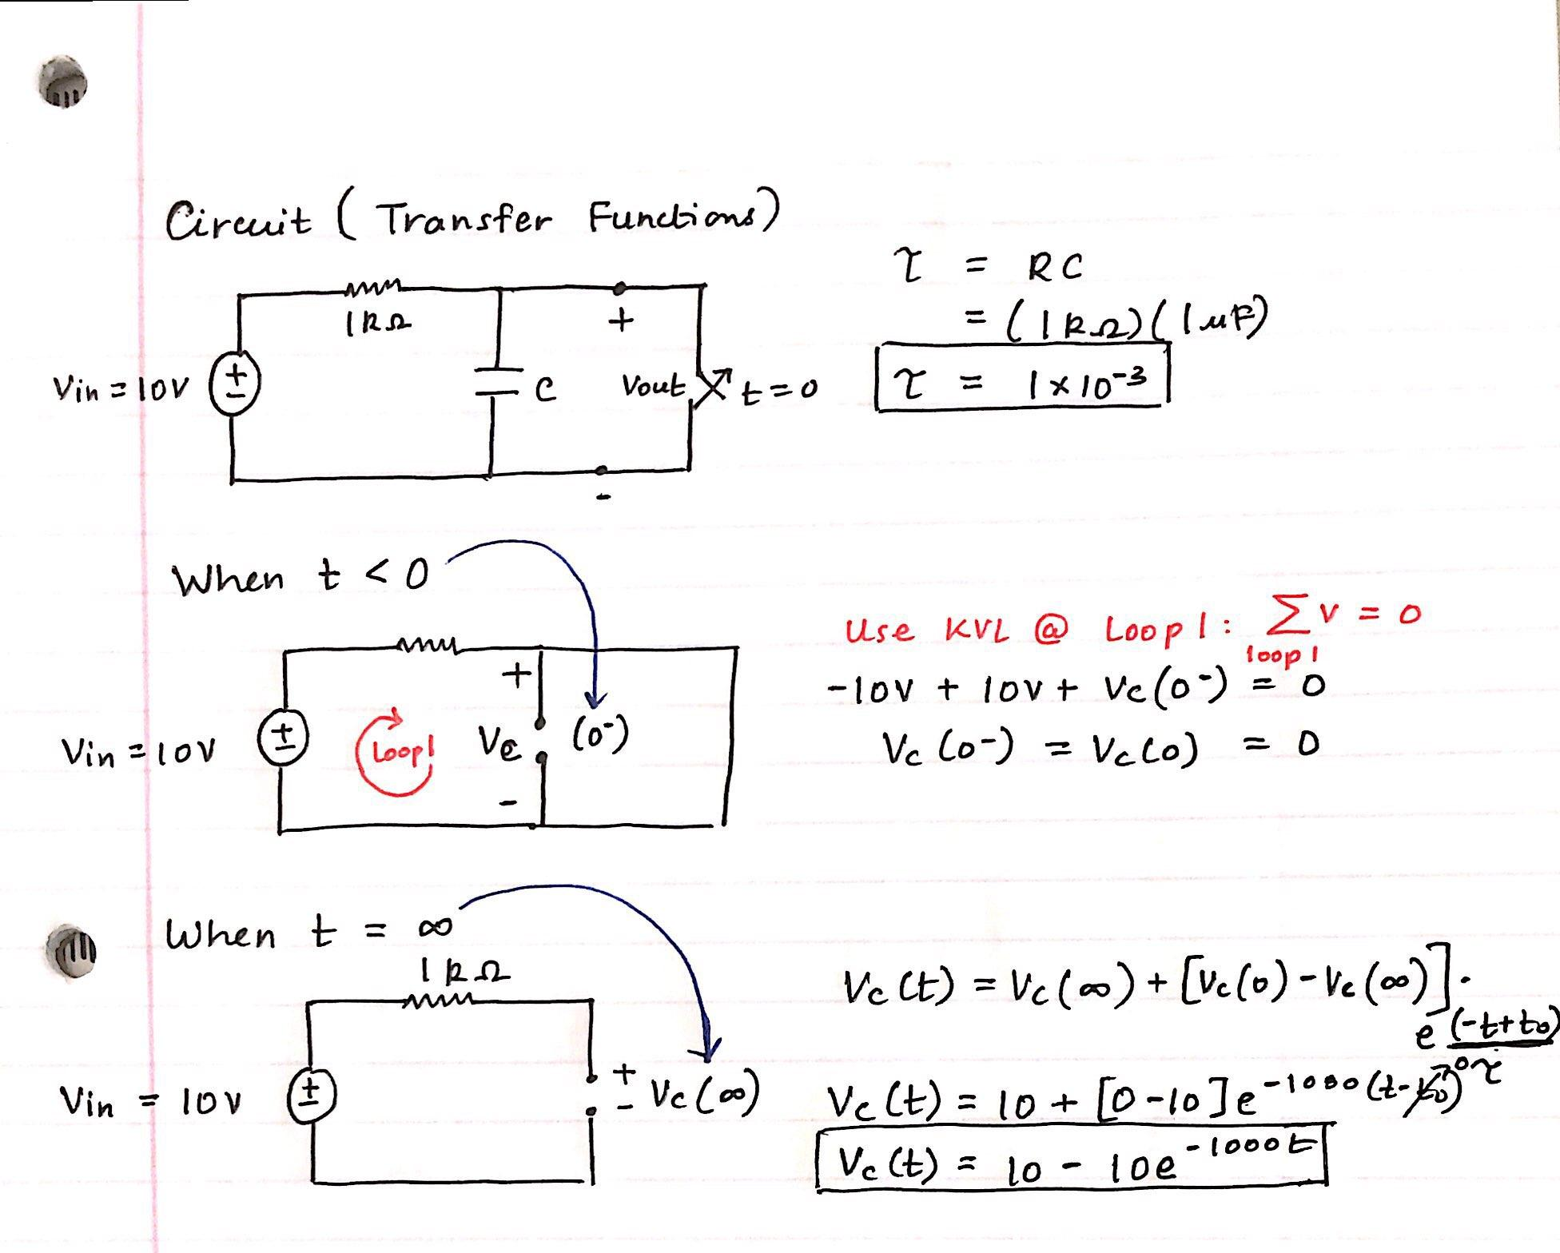

Table 4.1: Calculations of Transfer Functions (Theoretical)

|  |  |  |  |
| --- | --- | --- | --- |
|  | Capacitance | t < 0 | t = infinity |
| Transfer Function | T = 1 * 10^-3 | 0 | Vc(t) = 10 – 10e^100t |

______________________________

Sergio Aguilar Rudametkin